Task 2 – Superstore Sales Analysis
Objective
The objective of this analysis is to evaluate sales performance across regions, categories, products, customers, and time and identify important trends, seasonal patterns, and areas for improvement for Alfido Tech.
Data Preparation
The dataset was cleaned by checking missing values and duplicate records. Date columns were converted into proper date format, and additional features such as Year, Month, Quarter, and Shipping Days were created for analysis.
Key KPIs
- Total Revenue
- Total Orders
- Total Customers
- Total Products
- Average Order Value (AOV)
- Average Shipping Days
Profit margin and conversion metrics were not calculated because the dataset does not contain profit or conversion-related fields.
Key Analysis
The analysis includes:
- Monthly and yearly sales trends
- Regional sales performance
- Category and sub-category performance
- Top and bottom products by revenue
- Customer segment performance
- Shipping mode analysis
- Seasonal sales patterns
Key Findings
The visualizations help identify the strongest and weakest regions, categories, products, and customer segments. Monthly trends also highlight periods of higher and lower demand, which can support better sales and inventory planning.
Tactical Recommendations
- Focus marketing efforts on high-performing regions while improving weaker markets.
- Maintain sufficient inventory for high-revenue products.
- Review low-performing products for repricing, bundling, or replacement.
- Plan inventory and promotions according to seasonal demand.
- Optimize shipping options to improve delivery experience and efficiency.
Deliverables
Notebook / Code: https://www.kaggle.com/code/chanchalkarnawat/task-2
Screenshots & Visualizations:
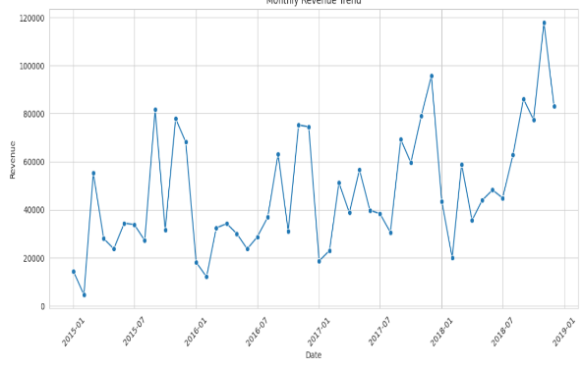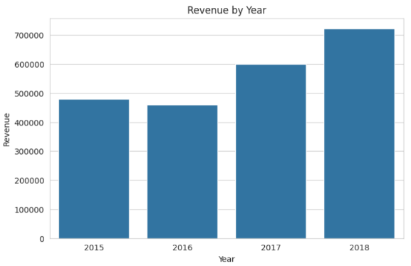

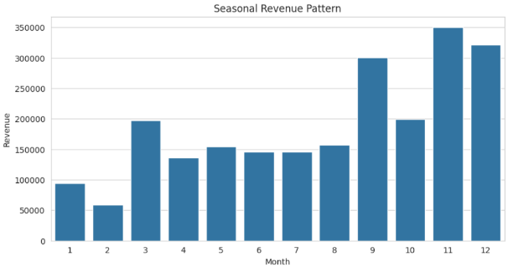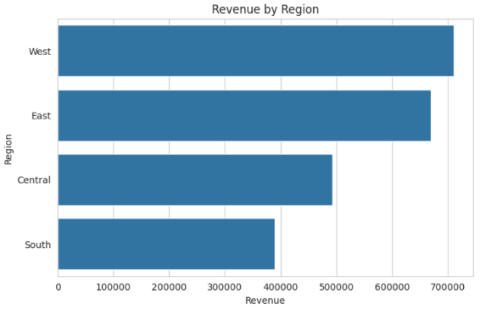

Conclusion
The analysis provides a data-driven view of sales performance and highlights opportunities for regional targeting, product optimization, seasonal planning, and improved customer experience.

